Name: __________________________________ Date: __________________

Period: ________________

I. Using a Microscope

Skills
* using a compound light microscope
* making a wet mount

Objectives
* Demonstrate the proper use and care of a compound light microscope
* Focus the compound light microscope at low power and at high power
* Make a wet-mount slide to examine under the microscope

Materials
* Compound light microscope
* prepared slide
* glass slides
* coverslips
* water
* paper towel
* toothpick
*newspaper

Purpose
You will be trained on the use of a compound light microscope while learning how to make a wet-mount slide.

Parts of the Compound Light Microscope

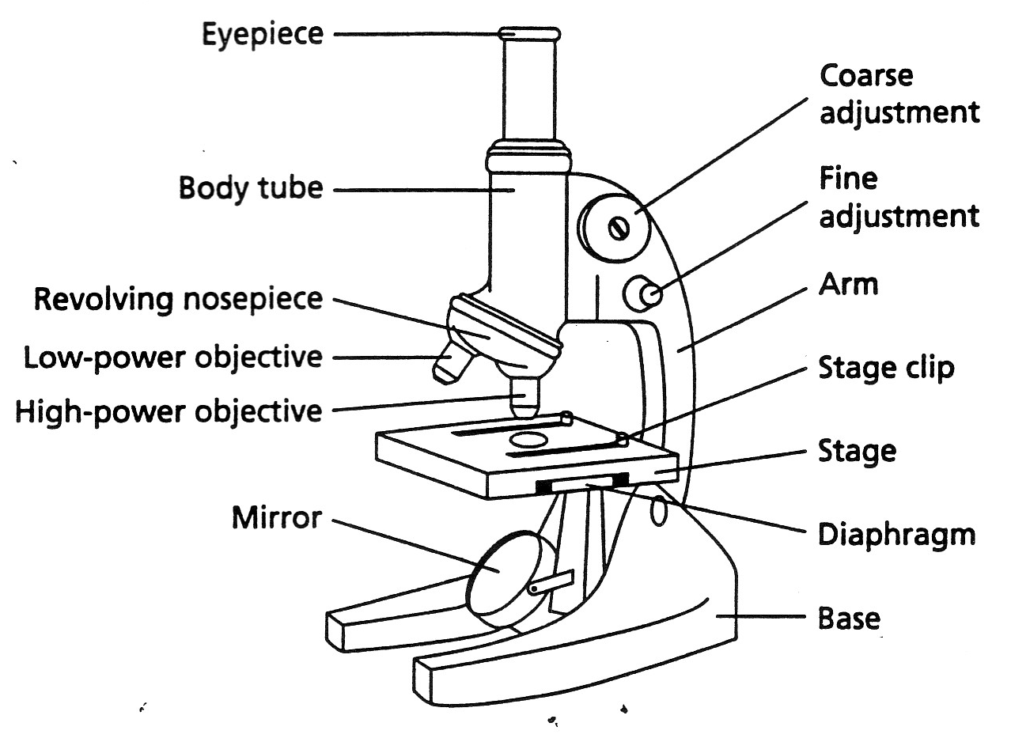

PROCEDURE:

Focusing the Microscope

- Identify the magnification power (number followed by an X) of the eyepiece and the low- and high- power objectives.
- Raise the objectives (or lower the stage) as far as possible by turning the course-adjustment knob toward you. Obtain a prepared slide and secure it to the stage. Turn the low-power objective into position over the stage. Position the objective as close to the slide without touching it.
- Look through the eyepiece. Focus with the course-adjustment knob by turning it away from you.
- Complete focusing by slowing turning the fine-adjustment knob back and forth. When the object you are viewing is in focus and exactly in the middle of your field of vision. (If switching to high power NEVER use the course-adjustment knob)

Making a Wet Mount

- Use scissors to cut out a capital letter R from a piece of newspaper (regular small type).
- With a medicine dropper, place one drop of water in the middle of a clean glass microscope slide.
- With forceps, place the letter R in the drop of water as seen in the diagram.
- Hold a coverslip at a 45º angle to the slide at the edge of the drop of water as seen in the diagram on the next page. Lower the coverslip slowly to avoid forming air bubbles.
- Place your wet mount on the microscope stage with the letter R facing you.
- Using the low-power objective, center and focus the microscope on the letter R.
- Then switch to high power

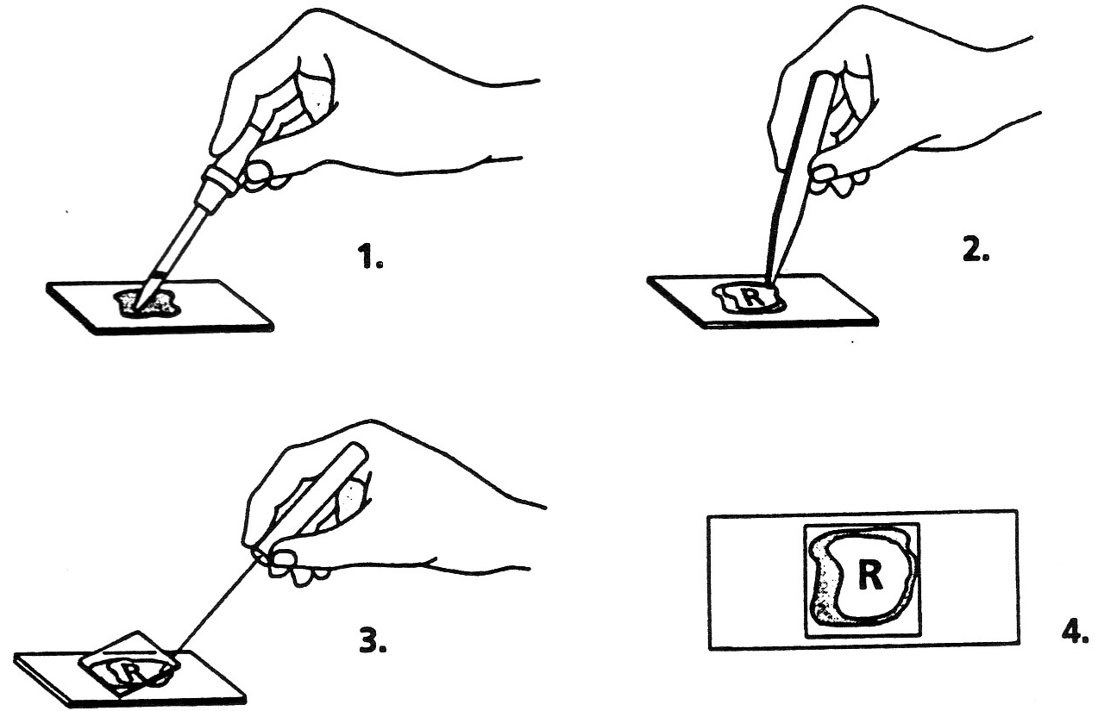

Questions

1. What happens to the image of the letter R as you go from low to high power? _________________________

2. What happens to the image of the letter R as you move the slide to the right? __________________________

3. What happens to the image of the letter R as you move the slide to the left? __________________________

4. Move the slide away from you, and record what happens to the image. _______________________________
II. Plant and Animal Cells

Objectives
* Demonstrate proper technique for preparing and staining wet mounts.
* Review cell structures and their functions
* Identify cell structures specific to plant cells
*Compare plant and animal cells

Materials
* Compound light microscope
* Onion
* Elodea plants or Other Plant Cell
* prepared slides for the following:
Human blood cells
human cheek epithelium (if your state permits the use of tissues)
* microscope slides
* coverslips
* Lugol’s solution (stain)
* medicine dropper
* paper towel
* forceps

PROCEDURE

PART A: Plant Cells

- Obtain a section of onion and separate the layers.
- Hold one of the layers so that it curves toward you. Bend the layer of the onion sharply so the shiny back surface snaps, exposing a THIN membrane on the inner surface.
- Using forceps, peel of a SMALL piece of the thin membrane, called epidermis, from the inner surface of the onion layer. Place the epidermis on a microscope slide, flattening it completely with the forceps.
- Use a medicine dropper to prepare a wet mount of the piece of epidermis. Don’t forget the cover slip. Examine the epidermis under low power.
- Remove the slide from the microscope. Using a medicine dropper, place a drop of Lugol’s solution at one edge of the coverslip. Place a small piece of paper towel on the opposite edge to draw the iodine solution under the coverslip, as shown in the figure below.
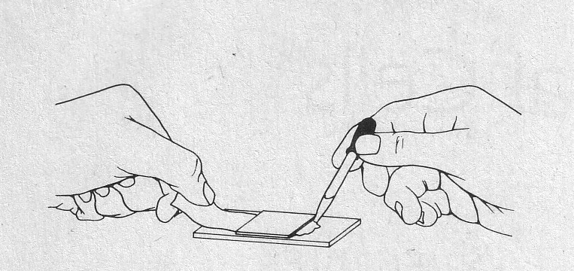

- Examine the stained onion epidermal cells under low power. Note the appearance and compare it to the unstained cells. Switch to high power. Make a diagram of the stained onion cells in item 4 of Part A in the Observations & Data.

- Get a sprig from the aquatic plant Elodea or a prepared Plant slide.. Pull off a small leaf and place the upper surface down on your slide. Flatten it with your forceps.

- Prepare a wet mount and stain it with Lugol’s solution. Examine the Elodea first under low power, then under high power. Make a diagram of what you see under high power for item 5 of Part A in the Observations & Data.

PART B: Animal Cells

- Study a prepared slide of human blood cells and place it on your microscope stage. Examine the slide under low power.
- Switch to high power and examine the cells again. Diagram what you see under high power for item 1 of Part B in the Observations & Data.

- Obtain a prepared slide of human cheek epithelial cells. Examine the slide under low power, and note how the cheek cells are different from the plant cells of Part A.
- Switch to high power and examine the cells again. Answer questions 2 and 3 of Part B in the Observations & Data. Diagram what you see under high power for item 4 of Part B in the Observations & Data.

- Before leaving the laboratory, clean up ALL materials. Wash your hands thoroughly with soap and water.

OBSERVATIONS AND DATA

PART A: Plant Cells

1. What evidence do you see that an onion is a plant cell?
_______________________________________________________________________________________

2. What structures can be seen in an unstained onion cell?
3. Onion cells do not have chloroplasts. How can you identify them as plant cells?

4. Stained Onion Epidermal Cells

X

5. Elodea Cells

X

6. Why are there no chloroplasts in onion epidermal cells like the ones you observe in the elodea leaves?

7. How are Elodea cells different in appearance from onion cells?

PART B: Animal Cells

- Human Blood Cells

X

2. How are animal cells different from plant cells?

3. How do you know you are not looking at a plant?

4. Human Cheek Epithelial Cells

X

