Laboratory Equipment Alternate

Introduction

In this activity you will cut out the various pieces of equipment that could be used throughout this course and place them in the proper location on the laboratory equipment handout. Your goal is to identify the name of the piece of equipment using the word bank to help you. In addition, you will look at the piece of equipment and try to determine its function.

5

ANd9GcT-L9lkLs56gTbx1zNTfAiWov7e8DqqmtvJEE6dFGlu7Q3FvV3ZsejXDUI 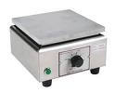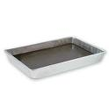 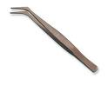  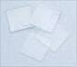

6

4

3

2

1

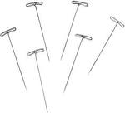 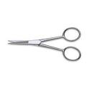 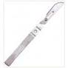 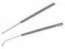  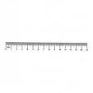

12

11

10

9

8

7

18

17

16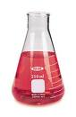

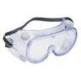  [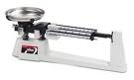](http://www.google.com/imgres?imgurl=http://www.medicalscale1.com/wp-content/uploads/2010/11/triple-beam-balance-scale7.jpg&imgrefurl=http://www.medicalscale1.com/category/triple-beam-balance-scale/&usg=__EbhqehlfH72iRU2n25FaI2WvjDQ=&h=362&w=600%20) 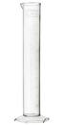 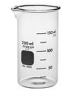 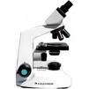

15

14

13

23

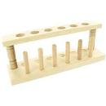 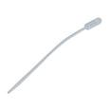 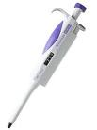 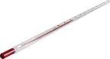  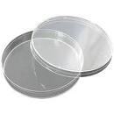

24

22

21

20

19