Safety in Biology

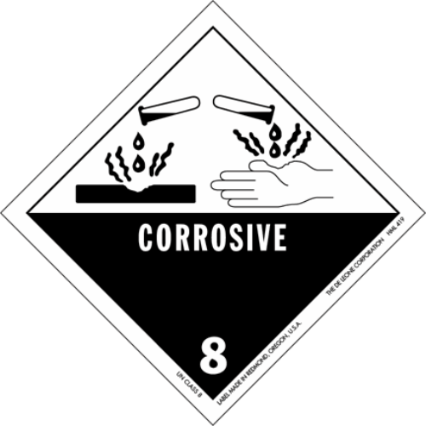

**What does this sign mean?**

If a substance is corrosive, it can eat through objects. Many scientists have to work with chemicals that are corrosive or otherwise dangerous. That's one reason that following safety precautions in the [laboratory](https://www.ck12.org/c/biology/laboratory) or field is very important.

**Safety in the Life Sciences**

There can be some very serious safety risks in scientific [research](https://www.ck12.org/c/chemistry/research). If researchers are not careful, they could poison themselves or contract a deadly illness. The kinds of risks that scientists face depend on the kind of research they perform. For example, a scientist working with [bacteria](https://www.ck12.org/c/biology/bacteria) in a [laboratory](https://www.ck12.org/c/biology/laboratory) faces different risks than a scientist studying the behavior of lions in Africa, but both scientists must still follow safety guidelines. Safety practices must be followed when working with the hazardous things such as parasites, radiation and radioactive materials, toxins, and wild [animals](https://www.ck12.org/c/biology/animals). Also, **carcinogens**, which are chemical that cause [cancer](https://www.ck12.org/c/biology/cancer), **pathogens**, which are disease-causing [virus](https://www.ck12.org/c/biology/virus), [bacteria](https://www.ck12.org/c/biology/bacteria) or [fungi](https://www.ck12.org/c/biology/fungi), and **teratogens**, which are chemical that cause deformities in developing embryos, are extremely hazardous, and extreme care must be used when working with these items as well. For example, scientists studying dangerous organisms such as *Yersinia pestis*, the cause of bubonic plague, use special equipment that helps keep the organism from escaping the lab.

A **biohazard** is any biological material that could make someone sick, including disease-causing organisms. Therefore, a used needle is a biohazard because it could harbor [blood](https://www.ck12.org/c/biology/blood) contaminated with a disease-causing organism. [Bacteria](https://www.ck12.org/c/biology/bacteria) grown in a laboratory are also biohazards if they could potentially cause disease.

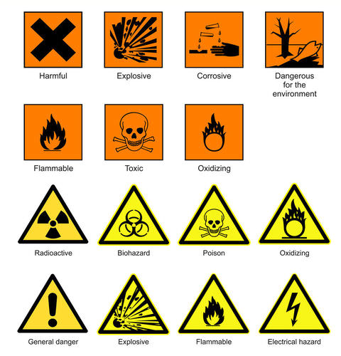

Science laboratory safety and chemical hazard signs.

**Laboratory Safety**

If you perform an [experiment](https://www.ck12.org/c/biology/experiment) in your classroom, your teacher will explain how to be safe. Professional scientists follow safety rules as well, especially for the study of dangerous organisms like the bacteria that cause bubonic plague (**Figure** [below](https://www.ck12.org/c/life-science/safety-in-the-life-sciences/lesson/Safety-in-the-Life-Sciences-MS-LS/?referrer=concept_details#x-ck12-TVNMUy0wMS0yNC1wbGFndWUtc2FmZXR5)).

Sharp objects, chemicals, [heat](https://www.ck12.org/c/chemistry/heat), and electricity are all used at times in laboratories. Below is a list of safety guidelines that you should follow when in the laboratory:

* Be sure to obey all safety guidelines given in lab instructions and by your teacher.
* Follow directions carefully.
* Tie back long hair.
* Wear closed toe shoes with flat heels and shirts with no hanging sleeves, hoods, or drawstrings.
* Use gloves, goggles, or safety aprons when instructed to do so.
* Broken glass should only be cleaned up with a dust pan and broom. Never touch broken glass with your bare hands.
* Never eat or drink anything in the science lab. Table tops and counters could have dangerous substances on them.
* Be sure to completely clean materials like test tubes and beakers. Leftover substances could interact with other substances in future experiments.
* If you are using flames or [heat](https://www.ck12.org/c/chemistry/heat) plates, be careful when you reach. Be sure your arms and hair are kept far away from heat.
* Alert your teacher immediately if anything out of the ordinary occurs. An accident report may be required if someone is hurt. Also, the teacher must know if any materials are damaged or discarded.

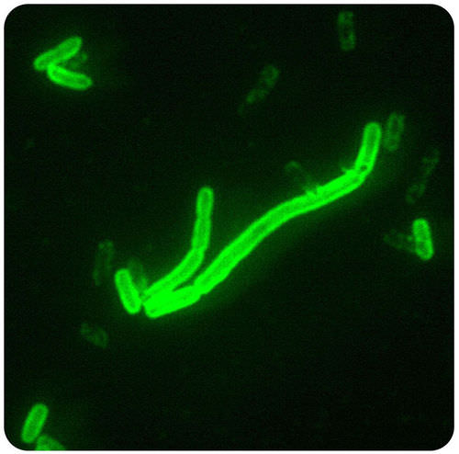

Scientists studying dangerous organisms such as *Yersinia pestis*, the cause of bubonic plague, use special equipment that helps keep the organism from escaping the lab.

**Field**[**Research**](https://www.ck12.org/c/chemistry/research)**Safety**

A **field scientist** studies an organism in a natural setting, which is not usually an indoor laboratory. Scientists who work outdoors are also required to follow safety regulations. These safety regulations are designed to prevent harm to themselves, other humans, [animals](https://www.ck12.org/c/biology/animals), and [the environment](https://www.ck12.org/c/chemistry/the-environment). If scientists work outside the country, they are required to learn about and follow the laws and restrictions of the country in which they are doing [research](https://www.ck12.org/c/chemistry/research). For example, entomologists following monarch butterfly (**Figure** [below](https://www.ck12.org/c/life-science/safety-in-the-life-sciences/lesson/Safety-in-the-Life-Sciences-MS-LS/?referrer=concept_details#x-ck12-TVNMUy0wMS0yNS1tb25hcmNoLWJ1dHRlcmZseQ..)) migrations between the United States and Mexico must follow regulations in both countries. Before biologists can study protected wildlife or plant [species](https://www.ck12.org/c/biology/species), they must apply for permission to do so, usually from the government. This is important to protect these fragile species. For example, if scientists collect rare butterflies, they must first get a permit. They must also be careful to not disturb the habitat.

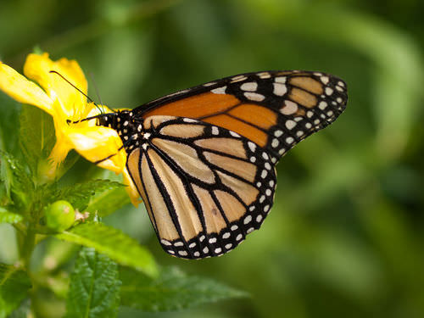

A monarch butterfly.

**Summary**

* There are serious risks in scientific research, including carcinogens, biohazards, and toxins.
* You need to carefully follow all safety rules while working in the laboratory.

**Review**

1. What is a biohazard?
2. List three hazards found in scientific research.
3. List three safety guidelines that you should follow in the laboratory.