1. Paramecium

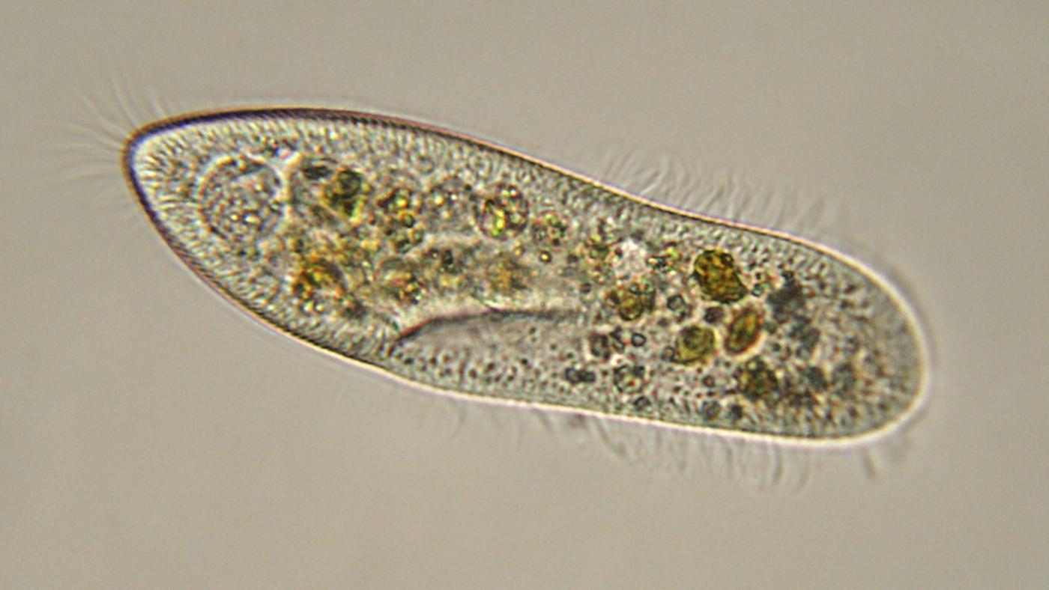

The paramecium lives in water. It is made of a single cell and contains a nucleus. It moves by beating the cilia on its sides. It gets energy by eating other single-celled organisms.

2.Anole Lizard

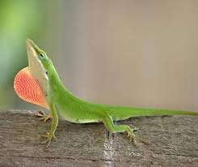

Anole lizards are made of eukaryotic cells. They live on land their whole lives and eat insects. They lay eggs with shells. They have backbones and legs. They are covered in scales.

3.Whitetail Deer

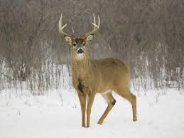

The whitetail deer is an herbivore that eats acorns, fruit and corn. Their special stomachs allow them to eat some things humans cannot, such as mushrooms and poison ivy.

4. Fern

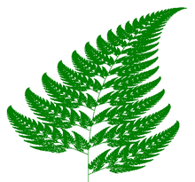

Ferns live on land. They reproduce by producing spores. They get energy from the sun and cannot move.

5.Water Lily

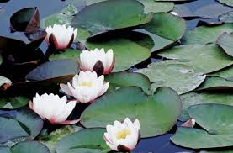

Water lilies live in the water. They reproduce by producing flowers with seeds. They get their energy from the sun and cannot move.

6.Mushroom

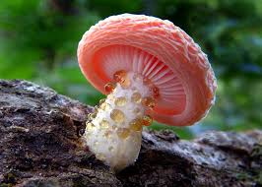

Mushrooms get their energy by digesting dead things. They reproduce by producing spores and cannot move.

7. Swordfish

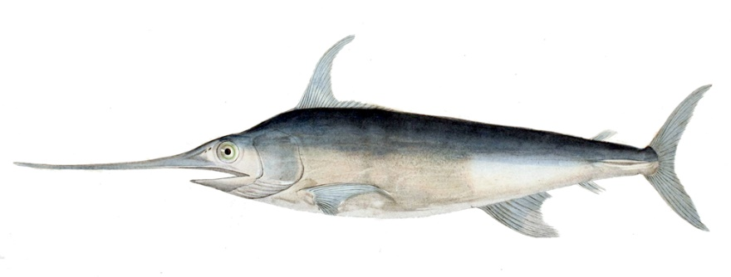

Swordfish lives in salt water and eat smaller fish. They reproduce by laying eggs that do not have shells. They have many bones, including a backbone. They are covered in scales.

8. Hydra

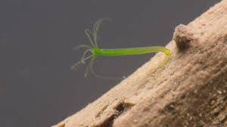

Hydra are microscopic organisms made of eukaryotic cells. They live in fresh water. They do not have bones or muscles and eat by stinging smaller prey and taking the food into a digestive tube, They can reproduce sexually or by budding a new hydra off their side.

9. Butterfly

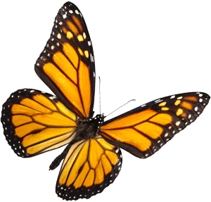

Butterflies have three segments in their body. They live on land but do not have bones. They get their energy from the nectar of flowers. Butterflies reproduce sexually and lay eggs without shells. They have six legs.

10. Human

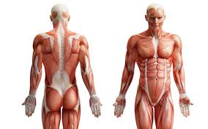

Humans have bones, can move, and eat both plants and animals. They live on land and give birth to live young.

11. Eagle

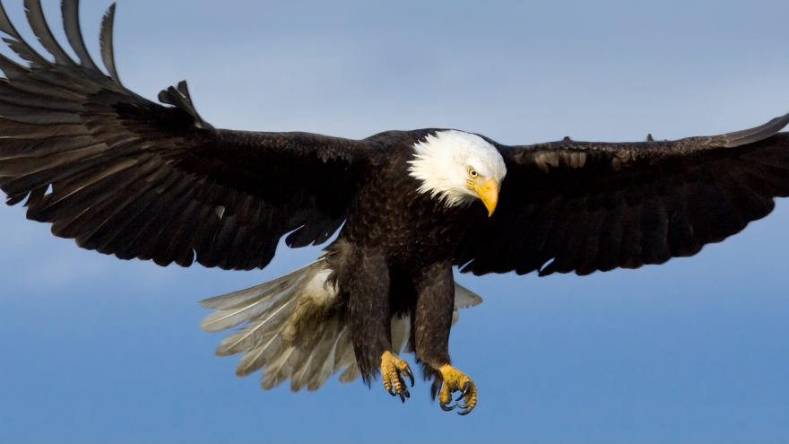

Eagles eat small animals. The bones in their forelimbs are adapted for flight and they have backbones. They lay eggs in shells. Their bodies are covered in feathers and their feet are covered in scales.

12. Starfish

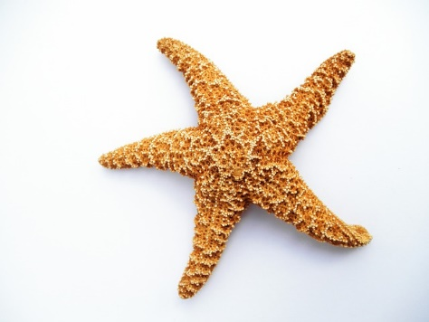

Starfish do not have bones, but are covered with a spiney surface but it is not a hard surface. They eat smaller prey by stuffing them into a central mouth. Starfish can reproduce sexually or asexually.

13. Snails

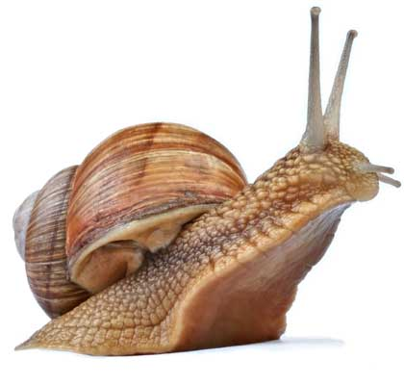

Snails have no bones, but are covered in a hard shell. They reproduce by laying eggs without a shells. They generally spend some time in water and some time on land.

14. Pine Tree

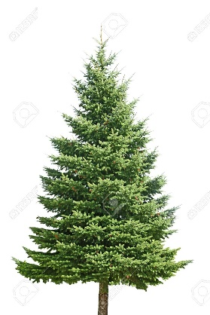

Pine trees live on land. They are woody plants with needle-like leaves that capture energy from the sun. They reproduce sexually with seeds in cones. They can’t move.

15. Planaria

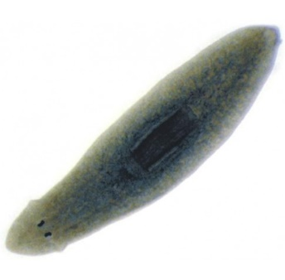

Planaria are tiny flatworms that are just visible without a microscope. They eat by sucking algae into a central gullet. They have no bones and must live in water. They are made of eukaryotic cells.

16. E. Coli

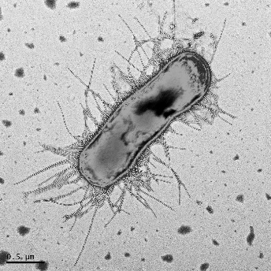

E coli are microscopic single-celled prokaryotes. They live by absorbing nutrients from their environment. They often live inside other organisms.

17. Seaweed

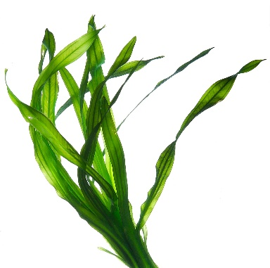

Seaweed is a collection of eukaryotic cells that are not organized into tissues. It makes it’s own food from sunlight. It cannot live on land and reproduces asexually.

18. Amoeba

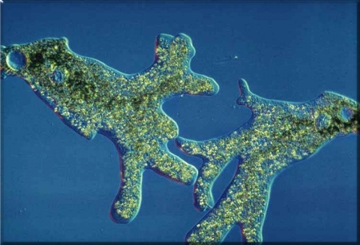

Amoebas are single-celled eukaryotic organisms. They live in water and can reproduce sexually or asexually. They move by extending pseudopods. They eat smaller single-cells organisms, such as planaria.

19. Yeast

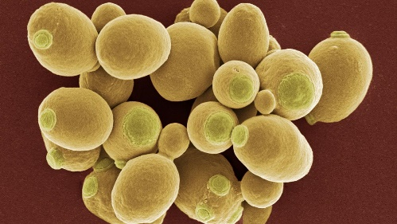

Yeast are unicellular organisms. They reproduce asexually. Yeast eat living and dead organisms. They have chitin in their cell walls.

20.Euglena

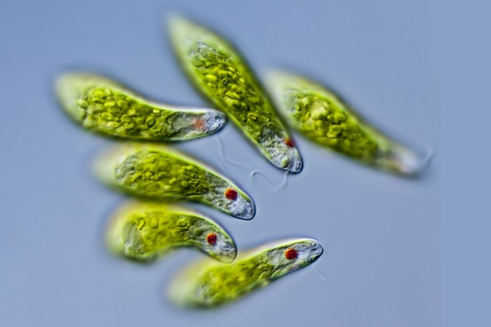

Euglena are unicellular organisms, which have a nucleus. They live in both fresh and salt water. They move using a flagellum. Euglenas have chloroplasts, to absorb sunlight. If sunlight is not available, it can absorb nutrients from decayed organic material.

21. Hell Bender

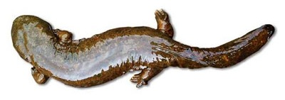

The bell bender reproduces in the water by external fertilization. They feed primarily on crayfish and small fish.

22.Deer Tick

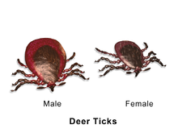

The deer tick is a parasitic organism that feeds on the blood of animals like the whitetail deer. They tend to live in wooded areas.

23. Maple Tree

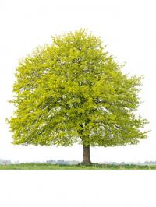

Maple Trees live on land. They are angiosperms. They have broad leaves, used to capture energy from the sun. They produce V-Shapes, double winged fruit about ½-1inch long in the spring.

24. Staphylococcus

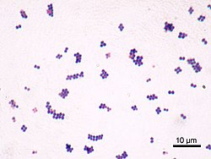

Staph are unicellular organisms lacking a nucleus. Their usual habitat is animal skin and mucosal surfaces. They reproduce asexually.

25. Streptococcus

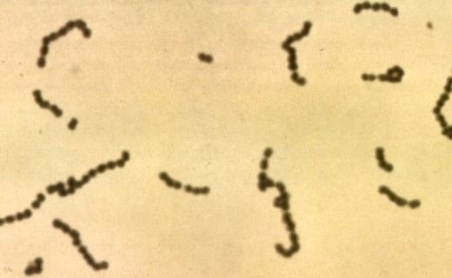

Stept. is a bacteria that forms the itching of the throat, laryngitis and much more. They reproduce asexually.

26. Bacillus

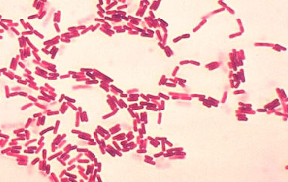

Bacillus are unicellular heterotrophs that live on simple sugars and amino acids. They can live in both water and on land.

27. Cyanobacteria

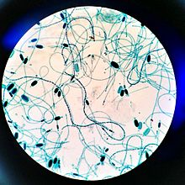

Cyanobacteria are unicellular organisms with free DNA. They are autotrophic and can be found in almost every conceivable environment, from oceans to fresh water to bare rock and soil.