Laboratory Safety -Bell Ringer

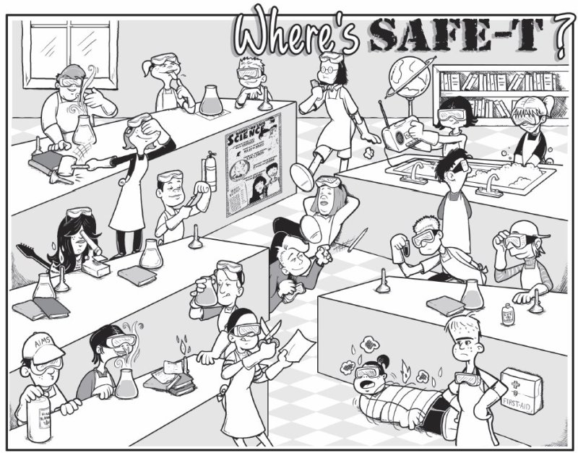

Identify at least 6 safety concerns in this lab picture and explain why it is a concern.



Identify 3 pieces of safety equipment in the picture and look around the classroom to see if you can find it in this room.