Experimental Design Exam

Name:________________________________________Date:___________

Part 1: Identify the equipment by matching the correct letter with the names of each piece of equipment.

.

1.___E__micropipette

2.___A__beaker

3.___C__graduated cylinder

4.___D__ funnel

5.___B__test tube

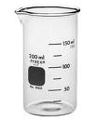

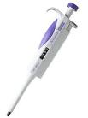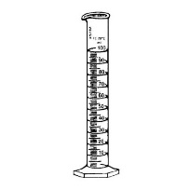ANd9GcT-L9lkLs56gTbx1zNTfAiWov7e8DqqmtvJEE6dFGlu7Q3FvV3ZsejXDUI

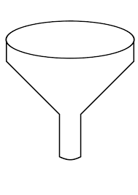

C

B

A

E

D

6. While trying out a new drug that may help patients increase their concentration, scientists decided to give the real pill to one group of patients while they gave the other group of patients a sugar pill. The patients were not told which group they were in. Why were the patients not told which pill they were taking?

A to keep patients from becoming angry

B to prevent bias when collecting data

C to prevent errors when collecting data

D to keep patients from dropping out of the study

Use the technical passage below to answer Numbers 7 and 8.

SCIENTISTS EXPLORE AN ASPECT OF FISH MIGRATION

Toxic pollutants from agriculture and industry have been found worldwide, even in areas that are far from pollution sources. Until now, scientists have blamed air currents for spreading toxins far from their sources. However, a recent study indicates that fish can transport toxins over long distances.

Scientists developed this hypothesis when toxins were mysteriously found in a remote lake in Sweden. A team of scientists from Lund University hypothesized that salmon accumulated and stored toxins in their fatty tissues when they were in the Baltic Sea. The salmon migrated upstream, spawned, and then died in the lake, releasing toxins as their bodies decomposed.

To test this hypothesis, the scientists traveled to Alaska, where they carried out an experiment in two neighboring lakes, Lower Fish Lake and Round Tangle Lake. Lower Fish Lake is open to migrating salmon, while Round Tangle Lake is closed to migrating salmon because of numerous waterfalls and rapids. A small fish, the arctic grayling, lives in both lakes. Fish eggs are a large part of its diet. When the scientists examined the arctic grayling from both lakes, the arctic grayling in Lower Fish Lake had more than twice the concentration of toxins in their bodies as the arctic grayling in Round Tangle Lake. Since both lakes are exposed to similar levels of air pollution, the difference in toxin levels found in the arctic grayling must be due to other factors.

In a related experiment, scientists caught salmon throughout their migration and tested their fatty tissues for toxins. Even though the fatty tissue deposits were gradually used up, toxin levels remained about the same throughout the 400-kilometer journey up the Copper River from the Gulf of Alaska to Lower Fish Lake. Instead of metabolizing the toxins, the salmon stored them in other body tissues that also contain fat, and in their eggs.

Both of these studies support the hypothesis that migrating salmon can transport pollutants to new areas.

7. According to the passage, what question is being asked by Lund University researchers?

A What are the migrating habits of salmon in Alaska and Sweden?

B Are increasing levels of air pollution affecting salmon migration?

C What are the diets of the arctic grayling and the migrating salmon found in the two Alaskan lakes?

D Are migrating salmon responsible for transporting toxins from the sea to freshwater lakes?

8. Which of these locations was used as the control in the experiment?

A Lower Fish Lake

B the Gulf of Alaska

C the Copper River

D Round Tangle Lake

9. While experimenting with mealworms a student used her senses to record the color, smell and other observations of the mealworm into a data table.

What choice best represents the type of data was she recording?

A qualitative data

B quantitative data

C bias data

D insignificant data

10. A scientist saw an article on her social media page claiming that drinking lemon water could help you lose weight. Being skeptical the scientist wanted to determine if the claim was true.

Which of these was most likely used to affirm this scientific idea?

A. formulate a hypothesis

B. identify the problem

C. conduct an experiment

D. write a conclusion

11. A student wants to measure the volume of liquid for an experiment. Which of these would be the best tool for the student to use?

A test tube

B magnifying lens

C graduated cylinder

D compound microscope

12. A group of students studied the effect of light intensity on the rate of a cell process in Elodea plants. The students exposed Elodea plants to different light intensities. A gas was produced by the cell process. The amount of this gas was measured. The rate of the cell process was determined by the amount of gas produced. A graph of the students' measurements is shown below.

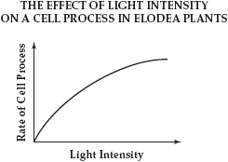

Which of these is the independent variable in this experiment?

A rate of cell process

B volume of gas

C size of Elodea plant

D intensity of light

13. The breathing rate of a goldfish can be measured by the number of times the goldfish opens its mouth. In an experiment, students placed a goldfish in a container of water at 26°C and counted the number of times the fish opened its mouth. They gradually lowered the water temperature and counted the number of times the fish opened its mouth at 20°C, 14°C, 8°C, and 2°C. The results are shown in the table below.

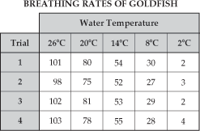

Which of these procedures would be a good control for this experiment?

A Use a different kind of fish for each water temperature.

B Determine the breathing rate of a goldfish kept at a constant 26°C.

C Put the goldfish in 2°C water and then increase the temperature.

D Repeat the experiment using a different species of goldfish.

14. Scientists are developing a microscopic submarine to deliver medicine to sites within the body. A biomotor that uses bacteria would move the submarine. The scientists are experimenting with several species of bacteria to find which one works best in the biomotor.

Which of these is the dependent variable in the scientists' experiment?

A the species of bacteria

B the movement of the submarine

C the size of the submarine

D the site within the body

15. Students will conduct a laboratory experiment using the following materials: a Bunsen burner, a beaker of water, glass tubing, four test tubes containing different chemicals, and rubber stoppers. Which of these steps is most critical for students to follow when using these materials in the lab?

A wearing eye protection at all times

B writing the lab procedure in a notebook

C washing hands before starting the experiment

D placing a stopper on all test tubes before heating them

16. A student performed an experiment to determine the relationship between air temperature and growth in plants. She divided 36 seedlings into six groups and grew each group at a different temperature. She recorded the average height of the plants in each group after a four-week period. Her results are shown below.

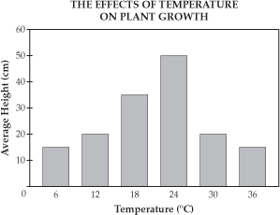

Which of these statements best describes the results shown in the graph?

A As temperature increases, the average height of the plants continually increases.

B Temperature only affects average height between 18°C and 24°C.

C As temperature increases, the average height of the plants first increases and then decreases.

D Average height levels off at a temperature of 18°C.

Use the information and the graph below to answer Numbers 17 and 18.

Scientists wanted to study the effect of water temperature on the swimming speed of goldfish. They set up an experiment in which they raised populations of goldfish in two different aquariums. Population 1 was raised at 5°C. Population 2 was raised at 25°C. All other variables were constant in both aquariums. The results of this experiment are shown in the graph below.

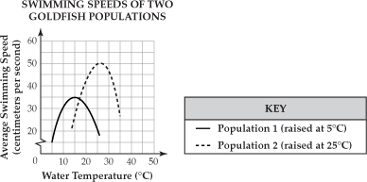

17. According to the graph, both populations of goldfish swim at the same speed at which of these temperatures?

A. 12°C

B. 17°C

C. 22°C

D. 27°C

18. According to the graph, as the water temperature increases from 5°C to 25°C, the average speed of the goldfish in Population 1

A increases

B decreases

C first increases, then decreases

D first decreases, then increases

19. A student’s hypothesis is that increased exercise causes increased heart rate. Heart rate is determined by taking the pulse, which is measured in beats per minute (BPM).

Which of the following data would support this student’s hypothesis?

A. When sitting, her pulse was 70 BPM; when standing, her pulse was 50 BPM.

B. When running, her pulse was 100 BPM; when sitting, her pulse was 60 BPM.

C. When sitting, her pulse was 90 BPM; when walking, her pulse was 90 BPM.

D. When running, her pulse was 65 BPM; when standing, her pulse was 70 BPM.

20. Constructed Response (answer on a separate lined paper):

Researchers tested a new product designed to remove mildew from household surfaces. They gave free samples of the product to 100 different households. They collected these data: 70 households reported that the product was effective in removing mildew; 30 households reported that the product was not effective in removing mildew. From these data, the researchers concluded that the product was 70% effective in removing mildew from household surfaces.

* Design an experiment to give more reliable results. (Total of 14pts, see below for the breakdown)

Include in your response,

* A hypothesis (4)
  + If the product is used then the mildew will decrease. Answers may vary.
* Appropriate list of materials (4)-answers will vary
  + Product x100
  + 100 Households with a mildew problem-Household surface (bathtub)

Other material (cloth to clean the surface)

Training for properly using the product

* Procedures (4)-answers will vary
  + Obtain 100 households with mildew who are willing to participate
  + Use the training to instruct the household how to properly use the product.
    - Clean the surface
    - Have participant use the product daily by covering the entire surface by misting the household surface.
    - Let the product sit for 2 minutes prior to using it the bathtub.
  + After 30 days the participant will record if there is any evidence of mildew in the data table.
  + Participant will mail/email the results
* A data table-it does not have to be filled out(2)

Example:

Title: The Effect of the Product on Mildew Growth

|  |  |  |
| --- | --- | --- |
| Household # | Growth (yes/no) | Qualitative Observations |
| Household #1 |  |  |